
SANDBAG PROTECTION

An inexpensive temporary barrier or wall, 1 to 2 feet high, can be constructed by stacking sand-filled or earth-filled sandbags. They can be placed to divert mud and other debris flows away from buildings. They will not, however, provide protection from high debris flows.

When to Use
- To protect building sites vulnerable to low mud debris flows from steep, erodible slopes that are partially or completely void of vegetation due to wildfire burns.

- As an inexpensive, temporary protection method for home before predicted rainfall.

Note: Sandbags deteriorate when exposed to continued wetting and drying for several months. If the bags need to be used for more than a few months, cement can be mixed with the sand. The cement and sand mixture will harden when the bags dry.

Methods and Materials
Sandbag barriers are easy to construct. Burlap bags, sand, plastic, lumber, cement and plywood are readily available at local lumberyards. Some fire stations and other emergency centers can also help with materials.
Place filled sandbags to direct debris flows away from buildings, pools, and other structures. Clear a path for the debris. Do not try to dam or stop debris flows.
Protect your most valuable property first. Debris can enter a building through doors and windows, so they should be boarded up and waterproofed with plastic sheets. Remember: Sandbags will not seal out water.
Work with your neighbors and be prepared to use your property to provide good protection for the community.

How to Fill Bags
Fill sandbags one-half full. Use sand, if available, or, local soil. Fold the top of the sandbag down and place the bag on its folded top (see illustration).

How to Place Bags
Refer to illustration. Place each sandbag as shown finishing each layer before starting the next. Limit placement to two layers unless they are stacked against a building or pyramided.
It is important to place bags with the folded top in the upstream or uphill direction facing the flow of water to prevent them from opening when water runs by.

July 2002 Arizona

Sandbag Protection

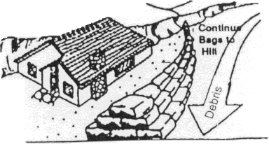

FILL HALF FULL FOLD TOP UNDER

PLACE BAG WITH FLAP UNDER BAG

