JUTE NETTING

Netting made of jute can be laid and anchored over straw or other mulch to help protect the soil from wind and water damage. Netting helps reduce soil erosion and provides a good environment for vegetative regrowth.
Jute is a biodegradable material that will eventually decompose and is not a threat to the environment or wildlife.

When to Use
Jute netting can be used on areas that may erode near structures such as homes, roads, and bridges or on small, steep, disturbed areas.
Netting can also be applied alone (without mulch) as an alternative to straw or wood mulches on flat sites for dust control and seed germination enhancement.
It should not be used alone where runoff quantities are expected to be high.
The use of jute netting is not appropriate in all situations. Examples of when it may not be appropriate:
- Steep slopes with sandy soils
- Steep slopes with many rocks on the surface
- Steep slopes with a significant amount of fire burned vegetation remaining

Specifications
The soil surface should be reasonably smooth. Remove rocks and other obstructions that rise above the level of the soil or mulch.
Jute netting should be cloth of a uniform plain weave of undyed and unbleached single jute yam. The materials should weigh about 1.2 pounds per linear yard and have approximately 78 warp ends per width of cloth and 41 weft ends per linear yard.
Most nurseries, hardware stores, and lumber yards can help find netting that meets these recommended specifications.
Individual rolls of jute should be applied up and down the slope--never along the contour.
Bury the upper end of the netting at the top of the disturbed area in a trench at least 6-8 inches deep.
Lay out rolls so edges overlap each other by at least 4 inches.
Extremely important: When more than one roll is required going down slope, the ends going down the slope should overlap by at least 3 feet.
Anchor the netting to the soil surface with anchor pins or staples. Anchor pins are made of rigid 0.12–inch diameter or heavier galvanized wire with a minimum length of 10 inches for hook or “J” type pins. Staples should be of wire .09 inch in diameter or greater and should have “U” shaped legs that are at least 6 inches long. Longer staples are needed for sandy soils.
Staples or anchor pins need to be driven perpendicular into the slope face and should be spaced about 5 feet apart down the sides and center of the roll.
Spacing between staples at the upper end of a roll and at the end overlap of 2 rolls should not be greater than 1 foot.
The netting should go beyond the edge of the mulched or seeded area at least 1 foot at the sides and 3 feet at the bottom. If there is vegetation at the boundaries of the area, the netting should be continued into the stable vegetated area or to the edge of a structure.

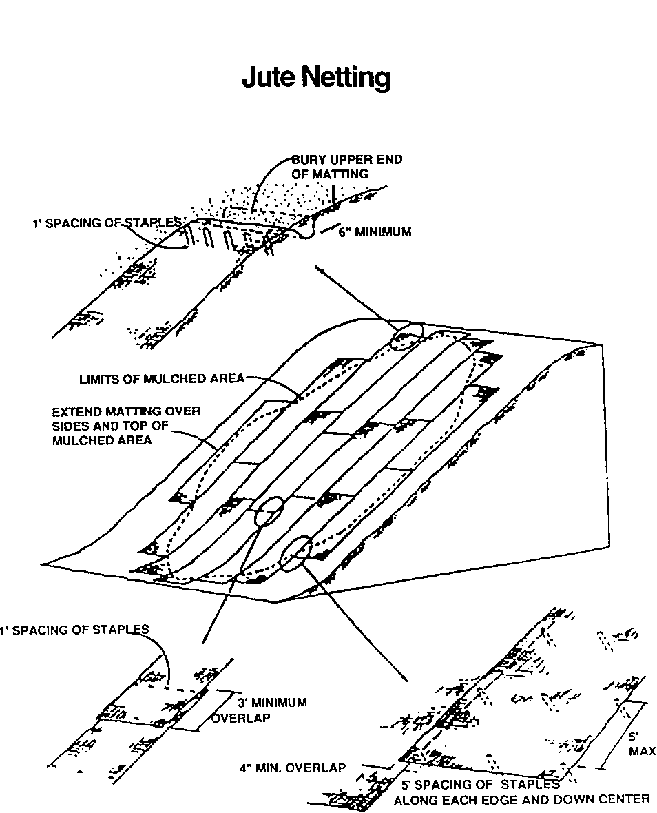
July 2002 Arizona

