GRANT APPLICATION PACKAGE
Arizona Community Challenge Grants

Please attach all required information in the order provided below.

REQUIRED
- Completed Grant Application Form – 1 page
- Completed Budget Proposal Form – 1 page
- Project Narrative – up to three (3) typewritten pages
- Budget Narrative – not to exceed one (1) page
- 5-Year Tree Maintenance Plan – not to exceed one (1) page

OPTIONAL
- Additional supporting material – not to exceed two (2) pages
- Letters of commitment – no more than three (3); no form letters accepted

Do not attach a cover letter to the application materials. The top sheet of your completed application should be the “Grant Application Form”. Please do not bind the application materials; a staple in upper left-hand corner is sufficient.

One (1) copy of the completed proposal must be submitted (via email, postal service, or in person) to the following address no later than 5:00 P.M., Friday, October 12, 2018. This means in the office by October 12, not postmarked by October 12.

Email: grants@dffm.az.gov

Arizona Department of Forestry and Fire Management
Urban & Community Forestry
1110 W. Washington, Ste100
Phoenix, AZ 85007-2935

Application deadline is Friday, October 12, 2018 at 5:00 P.M.

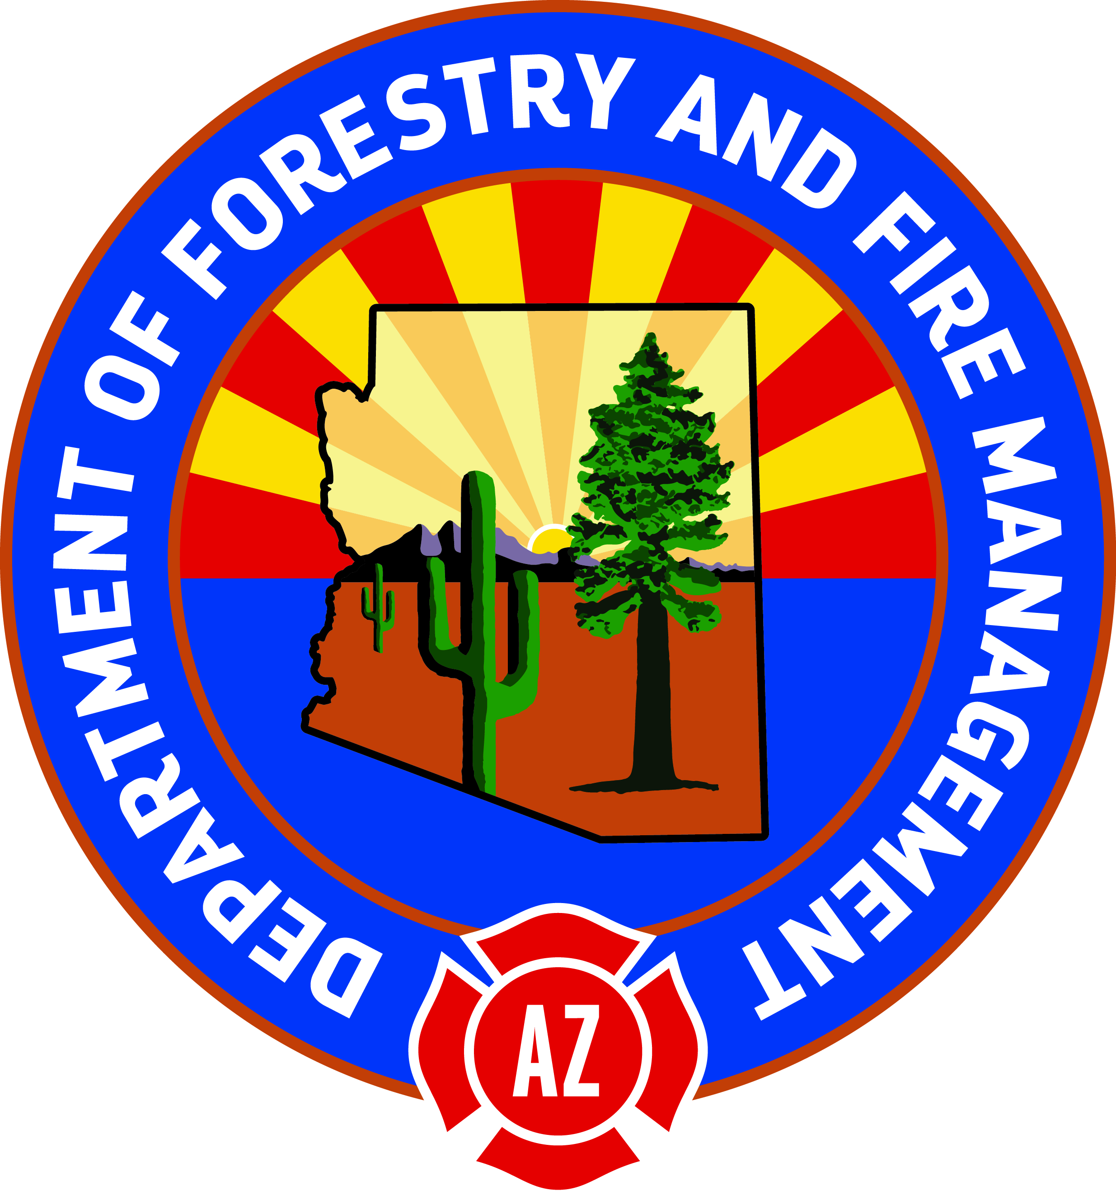

Project Number:
For U&CF Use Only
GRANT APPLICATION FORM

Arizona Community Challenge Grant Program

Project Title:
Category:
Location (City):
Tree City USA (if applicable): |  |  |  |  |  |  |  |  |  |  |  |  |  |  |  |  |  |  |  |  |  | Yes | No
Name of Applicant:
Address of Applicant:
City |  |  |  |  |  |  |  |  |  |  |  |  |  |  |  |  | State | AZ |  | Zip
Contact Person: |  |  |  |  |  |  |  |  |  |  |  | Daytime Phone:
E-Mail: |  |  |  |  |  |  |  |  |  |  |  | Organization’s DUNS #:
Brief Project Description: |  |  |  |  |  |  | (Please attach a separate, maximum 3-page narrative that clearly
states the project need, objectives, methods, and deliverables.)
Is this project currently funded? |  |  |  |  |  | Yes |  |  |  | No |  |  | Was this project previously funded? |  |  |  |  |  |  |  |  | Yes | No
Will this project be possible without grant funding? |  |  |  |  |  | Yes |  |  |  | No |  |  | Can this project occur with- out full requested amount? |  |  |  |  |  |  |  |  | Yes | No
(a) UCF Funds Requested |  |  |  |  |  |  |  | $ |  |  | 0.00
(b) Local $ Match Provided |  |  |  |  |  |  |  | $ |  |  | 0.00
(c) Value of In-Kind Match |  |  |  |  |  |  |  | $ |  |  | 0.00
Total Project Amount (a+b+c) |  |  |  |  |  |  |  | $ |  |  | 0.00
Timetable: |  | (Starting Date) |  |  |  |  |  |  |  |  |  |  |  |  |  | (Ending Date)
Volunteer Involvement [Name of Group(s)]:

Name of Representative |  |  |  |  |  |  |  |  |  |  |  |  |  |  | Title of Representative
Signature of Authorized Representative |  |  |  |  |  |  |  |  |  |  |  |  |  |  | Date

Upon authorization of approval for financial assistance, grantees will be assigned a grant number and a maximum dollar amount to expend. Prior to expending funds, applicants must submit an updated project workplan.

BUDGET PROPOSAL FORM
Project Number:
For U&CF Use Only
Arizona Community Challenge Grant Program

Applicant Name:
Project Title:
 |  | MATCH
Item | Grant Share  Direct Expenses or Cash Purchases | Applicant  Direct Expenses or Cash Purchases | Applicant  In-kind Personnel Services: Volunteer and Staff Hours | Applicant  In-kind Donated: Services, Supplies, or Equipment use | Total
Administration (Project-allocable general overhead costs) | $0.00 | $0.00 | $0.00 | $0.00 | $0.00
Personnel (Project-related Labor, both staff and volunteer time, Fringe Benefits) | $0.00 | $0.00 | $0.00 | $0.00 | $0.00
Contracted Services  (Forestry professionals, consultants, landscape architects, arborists, engineers, etc.) | $0.00 | $0.00 | $0.00 | $0.00 | $0.00
Supplies (itemize as necessary – plant materials, research materials, educational materials, postage, etc.) | $0.00 | $0.00 | $0.00 | $0.00 | $0.00
Other: | $0.00 | $0.00 | $0.00 | $0.00 | $0.00
TOTAL: | $0.00 | $0.00 | $0.00 | $0.00 | $0.00

This form is for the summary of your budget information. A detailed list of expenditures and a budget narrative should be provided on additional pages if necessary.

HELPFUL HINTS for COMPLETING YOUR APPLICATION

Arizona Community Challenge Grant Program

When drafting your proposal, please include the following information:

- Completed Application Form
- Completed Budget Proposal Form
- Proposal Narrative (maximum 3 pages)
  - Project Need and Justification Summary (recommend 1 paragraph)
  - Project Objectives and/or Goals
  - Project Methods – A narrative detailing how the project will be accomplished should include the following elements:
    - Activities (include scope of work)
    - Participants (project personnel, volunteers, corporate sponsor, etc.)
    - Timetable (include project start and end dates)
    - Anticipated Outcomes/Results
    - Evaluation (including what metrics will be used)
  - Programmatic Capability – Description of organizational and personnel experience implementing similar projects.
- Budget Narrative (maximum 1 page) – Discuss how each of the identified financial needs will be met.
- Optional Materials
  - Supporting documents – Letters of community support (limit three (3)).
  - Proposed projects that include tree planting require the following additional documents:
    - A detailed five (5) year maintenance plan specifying the entity responsible for maintenance and how it will be accomplished.
    - If trees will be planted within the Arizona Department of Transportation’s right-of-way, Grantee must provide proof of permission prior to planting.

