HNRCD Annual Plan of Work
2017-2018

District Name: Hereford Natural Resource Conservation District
Mission Statement: Working together to enhance our natural resources.
Supervisors
Member: James Lindsey Title:Chairman
Member: Lucinda Earven Title: Vice Chairman
Member: Rachel Thomas Title: Secretary
Member: John Ladd Title: Supervisor
Member: David Greenberg Title: Supervisor

Staff: Kathy Morris Title: Board Clerk

District Contact information
Kathy Morris
Board Clerk
Hereford NRCD
P.O. Box 3361
Sierra Vista, AZ 85636
520-220-2028

Location of Regular Board Meetings: Sierra Vista County Complex – Large Conference Room, 4001 E. Foothills Drive, Sierra Vista, AZ85635

Date and time of Regular Board Meetings: 3rd Wednesday of the month, 9:30 a.m.

District History/Powers/Authorities
The Hereford Natural Resource Conservation District, a local division of State Government, is authorized to identify and address resource conservation needs within its boundaries(ARS 37
Chapter 6). The elected District Board of Supervisors has the responsibility for determining those needs, for developing and coordinating long range plans and programs for natural resource conservation and implementing them under the District’s long range plan, and annual plan of work.

The District works with and coordinates its efforts with Federal, State and local governments, organizations, agencies and individuals to accomplish soil, water and species conservation. Arizona’s conservation district law is embodied in legislation and establishes the State’s natural resourcepolicy, carried out on a local level by the District.

The District also promotes a balanced environmental education program in the schools
and with workshops on many natural resource subjects.

Priority Natural Resource Concerns for our District:
Health of our watersheds
Soil erosion and sediment transport
Noxious Weeds and Invasive Species
Cultural Resources
Water Resources

Partners/Collaborators/Volunteers:
American Stewards of Liberty
Arizona Association of Conservation Districts
Arizona Department of Environmental Quality
Arizona Game and Fish Department
Arizona State Land Department
Cascabel Ranch & Consulting
City of Sierra Vista
Cochise Area Network for Therapeutic Equestrian Resources (C.A.N.T.E.R.)
Cochise Conservation and Recharge Network
Cochise County
Cochise County Fair
Coronado RC&D
Darling Geomatics
Douglas Field Office, NRCS
FBI Ag Enforcement Group
Fort Huachuca
Freeport McMoran
Howard G. Buffett Foundation
Iroquois Foundation
Sierra Vista Herald
Sierra Vista Ranger District, USFS
Tombstone High School FAA
Tucson Field Office, BLM
University of Arizona Department of Agriculture
Upper San Pedro Partnership
Walnut Gulch, Agriculture Research Service, USDA

Map of district
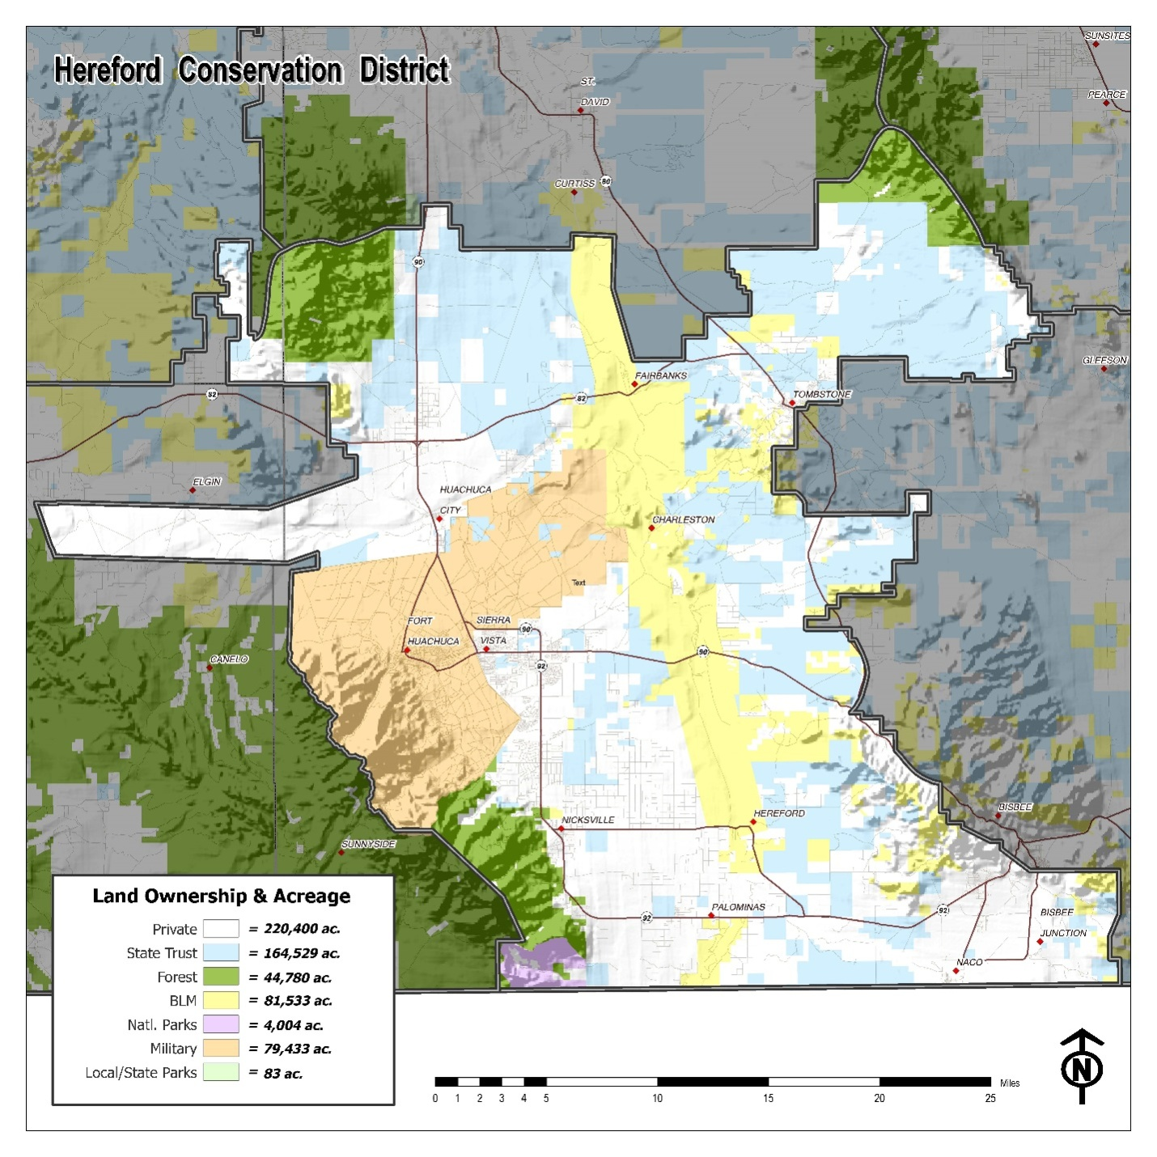

OVERARCHING ONE YEAR GOALSand SPECIFIC OBJECTIVES

Administration
- Hold monthly board meetings
- Hold special meeting and work sessions as required
- Publish a quarterly newsletter to keep cooperators and others informed of District activities and resource concerns
- Utilize the District website,www.herefordnrcd.com, to provide information including District and educational material, workshop announcements, meeting agendas, videos and Federal Agency Actions
- Actively seek grants that will benefit the natural resource goals of the District, City, and County governments
- Increase visibility of the District with state and national articles and press releases

AACD
- Attend and participate in meetings
- Coordinate with AACD to cultivate the NRCD program in Arizona

District Cooperators
- Increase cooperator base
- Provide technical assistance to cooperators on natural resource issues
- Have available Hereford NRCD signs for cooperators’ property

Coordination
- Coordination with policy makers and agencies on natural resource issues and plans
- Coordination with BLM on the San Pedro Riparian National Conservation Area Resource Management Plan
- Coordination with USFS on Forest Service Management Plans
- Coordination with USFWS on species listings, critical habitat and data
- Coordination with AZ Department of Agriculture on livestock diseases and control
- of diseases from livestock imported from Mexico

County Fair

Provide assistance, information and materials to the 4-H and FFA in the district for the county fair

PROJECTS

- Work with NRCS on conservation projects
- Work with district cooperators on projects for their property
- Arizona conservation partnership program
- Proceed with Phase 2, Horseshoe Draw Project
- Water Conservation
- Erosion control projects for large and small acreage land owners
- Brush control projects for large and small acreage land owners
- Water Quality - Monitor sediment and E.coli using survey grade fixed wing drones, which are unmanned aerial vehicles (UAVs), to monitor changes in topography

LEGAL ACTIONS

- A party to the Immigration Reform Law Institute lawsuit against Department of Homeland Security.

- A party on the Delisting Petition for the Yellow Billed Cuckoo

EDUCATION CENTER

Produce and acquire programs which provide education about resource management and make them available to schools in the District using the workshops, the web site, and the newsletter
- Provide support and assistance to the Tombstone High School FFA program to include the monitoring of the Arizona Game and Fish Department relocated antelope
- Ag education in the area schools
- Coordinate/provide in-school speakers
- Produce and present videos of tours, workshops and conservation practices for presentations and posting on District web site
- Provide support to the Natural Resource Conservation Workshop for Arizona Youth
- Encourage universities to utilize the District resource for field training
- Support 4-H activities within the District
- Develop and publish conservation fact sheets

Workshops/ Legislative Tour
- Host at least two workshops/ranch tours per year to provide information and education to the rural property owners in the District
- Invite local Arizona elected officials to visit local ranches and observe soil erosion programs with resultant grazing land improvements and water savings

Funding Sources

AdministrationFunded by State and District funds and volunteer work by supervisors
- Hold monthly board meetings.
- Hold special meeting and work sessions as required
- Publish a quarterly newsletter to keep cooperators and others informed of District activities and resource concerns
- Utilize the District website,www.herefordnrcd.com, to provide information including District and educational material, workshop announcements, meeting agendas, videos and Federal Agency Actions
- Actively seek grants that will benefit the natural resource goals of the District, City, and County governments
- Increase visibility of the District with state and national articles and press releases

AACDFunded by State and District funds and volunteer work by supervisors
- Attend and participate in meetings
- Coordinate with AACD to cultivate the NRCD program in Arizona

District CooperatorsFunded by State and District funds and volunteer work by supervisors
- Increase cooperator base
- Provide technical assistance to cooperators on natural resource issues
- Have available Hereford NRCD signs for cooperators’ property

CoordinationFunded by State, District funds and donations and volunteer work by supervisors
- Coordination with policy makers and agencies on natural resource issues and plans
- Coordination with BLM on the San Pedro Riparian National Conservation Area Resource Management Plan
- Coordination with USFS on Forest Service Management Plans
- Coordination with USFWS on species listings, critical habitat and data
- Coordination with AZ Department of Agriculture on livestock diseases and controlof diseases from livestock imported from Mexico

County FairFunded by State Education funds and volunteer work by supervisors

Provide assistance, information and materials to the 4-H and FFA in the district for the county fair.

PROJECTS

- Work with NRCS on conservation projects.Funded by NRCS, State, District funds, donations and volunteer work by supervisors

- Work with District cooperators on projects for their property. Funded by NRCS, State, District funds, donations and volunteer work by supervisors

- Arizona conservation partnership program Funded by Funded by AACD, NRCS, State, District funds and donations and volunteer work by supervisors

- Proceed with Phase 2, Horseshoe Draw ProjectFunded by State, District funds, Grants and volunteer work by supervisors

- Water Conservation Funded by NRCS, State, District funds and volunteer work by supervisors

- Erosion control projects for large and small acreage land owners
- Brush control projects for large and small acreage land owners

- Water Quality- Monitor sediment and E.coli using survey grade fixed wing drones, which are unmanned aerial vehicles (UAVs), to monitor changes in topography.Funded by State, ADEQ, District funds and volunteer work by supervisors

- LEGAL ACTIONSDistrict funds and volunteer work by supervisors & donations.

- A party to the Immigration Reform Law Institute lawsuit against DHS.
- A party on the Delisting Petition for the Yellow Billed Cuckoo

EDUCATION CENTERFunded by State Education Funds, District funds, grants and volunteer work by supervisors

Produce and acquire programs which provide education about resource management and make them available to schools in the District using the workshops, the web site, and the newsletter
- Provide support and assistance to the Tombstone High School FFA program to include the monitoring of the Arizona Game and Fish Department relocated antelope
- Ag education in the area schools
- Coordinate/provide in-school speakers
- Produce and present videos of tours, workshops and conservation practices for presentations and posting on District web site
- Provide support to the Natural Resource Conservation Workshop for Arizona Youth
- Encourage universities to utilize the District resource for field training
- Support 4-H activities within the District
- Develop and publish conservation fact sheets

Workshops/ Legislative TourFunded by State Education Funds, District funds, grants and volunteer work by supervisors

- Host at least two workshops/ranch tours per year to provide information and education to the rural property owners in the District
- Invite local Arizona elected officials to visit local ranches and observe soil erosion programs with resultant grazing land improvements and water savings

Who will do the work?
Administration:District Supervisors and District Clerk
- Hold monthly board meetings
- Hold special meeting and work sessions as required
- Publish a quarterly newsletter to keep cooperators and others informed of District activities and resource concerns
- Utilize the District website,www.herefordnrcd.com, to provide information including District and educational material, workshop announcements, meeting agendas, videos and Federal Agency Actions
- Actively seek grants that will benefit the natural resource goals of the District, City, and County governments
- Increase visibility of the District with state and national articles and press releases

AACDDistrict Supervisors and District Clerk
- Attend and participate in meetings
- Coordinate with AACD to cultivate the NRCD program in Arizona

District CooperatorsDistrict Supervisors and District Clerk
- Increase cooperator base
- Provide technical assistance to cooperators on natural resource issues
- Have available Hereford NRCD signs for cooperators’ property

CoordinationDistrict Supervisors, contractors, Cochise County and District Clerk
- Coordination with policy makers and agencies on natural resource issues and plans
- Coordination with BLM on the San Pedro Riparian National Conservation Area Resource Management Plan
- Coordination with USFS on Forest Service Management Plans
- Coordination with USFWS on species listings, critical habitat and data
- Coordination with AZ Department of Agriculture on livestock diseases and controlof diseases from livestock imported from Mexico.

County FairDistrict Supervisors and District Clerk

Provide assistance, information and materials to the 4-H and FFA in the district for the county fair.

PROJECTS

- Work with NRCS on conservation projectsDistrict Supervisors
- Work with district cooperators on projects for their propertyDistrict Supervisors and NRCS
- Arizona conservation partnership programAACD, NRCS, State, and District Supervisor
- Proceed with Phase 2, Horseshoe Draw ProjectDistrict Supervisors, ADEQ, and contractor
- Water Conservation District Supervisors, and NRCS
- Erosion control projects for large and small acreage land ownersDistrict Supervisors, and NRCS
- Brush control projects for large and small acreage land ownersDistrict Supervisors, and NRCS
- Water Quality -Monitor sediment and E.coli using survey grade fixed wing drones, which are unmanned aerial vehicles (UAVs), to monitor changes in topography. District Supervisors, ADEQ and Darling Geomatics

LEGAL ACTIONSContractors

- A party to the Immigration Reform Law Institute lawsuit against DHS.

- A party on the Delisting Petition for the Yellow Billed Cuckoo

EDUCATION CENTERDistrict Supervisors and District Clerk

Produce and acquire programs which provide education about resource management and make them available to schools in the District using the workshops, the web site, and the newsletter
- Provide support and assistance to the Tombstone High School FFA program to include the monitoring of the Arizona Game and Fish Department relocated antelope
- Ag education in the area schools
- Coordinate/provide in-school speakers
- Produce and present videos of tours, workshops and conservation practices for presentations and posting on District web site
- Provide support to the Natural Resource Conservation Workshop for Arizona Youth
- Encourage universities to utilize the District resource for field training
- Support 4-H activities within the District
- Develop and publish conservation fact sheets

Workshops/ Legislative TourDistrict Supervisors and District Clerk
- Host at least two workshops/ranch tours per year to provide information and education to the rural property owners in the District
- Invite local Arizona elected officials to visit local ranches and observe soil erosion programs with resultant grazing land improvements and water savings

When will the work be done?

AdministrationAll year
- Hold monthly board meetings.
- Hold special meeting and work sessions as required
- Publish a quarterly newsletter to keep cooperators and others informed of District activities and resource concerns
- Utilize the District website,www.herefordnrcd.com, to provide information including District and educational material, workshop announcements, meeting agendas, videos and Federal Agency Actions
- Actively seek grants that will benefit the natural resource goals of the District, City, and County governments
- Increase visibility of the District with state and national articles and press releases

AACDAll year
- Attend and participate in meetings
- Coordinate with AACD to cultivate the NRCD program in Arizona

District CooperatorsAll year
- Increase cooperator base
- Provide technical assistance to cooperators on natural resource issues
- Have available Hereford NRCD signs for cooperators’ property

CoordinationWhen determined necessary by the District Supervisors
- Coordination with policy makers and agencies on natural resource issues and plans
- Coordination with BLM on the San Pedro Riparian National Conservation Area Resource Management Plan
- Coordination with USFS on Forest Service Management Plans
- Coordination with USFWS on species listings, critical habitat and data
- Coordination with AZ Department of Agriculture on livestock diseases and controlof diseases from livestock imported from Mexico

County FairSeptember

Provide assistance, information and materials to the 4-H and FFA in the district for the county fair.

PROJECTS

- Work with NRCS on conservation projects All year
- Work with district cooperators on projects for their propertyAll year

Arizona conservation partnership programAll year
- Proceed with Phase 2, Horseshoe Draw Project
- Water ConservationAll year
- Erosion control projects for large and small acreage land ownersAll year
- Brush control projects for large and small acreage land ownersAll year
- Water Quality - Monitor sediment and E.coli using survey grade fixed wing drones, which are unmanned aerial vehicles (UAVs), to monitor changes in topography.All year

LEGAL ACTIONS

- A party to the Immigration Reform Law Institute lawsuit against DHS.

- A party on the Delisting Petition for the Yellow Billed Cuckoo

EDUCATION CENTERAll year

Produce and acquire programs which provide education about resource management and make them available to schools in the District using the workshops, the web site, and the newsletter
- Provide support and assistance to the Tombstone High School FFA program to include the monitoring of the Arizona Game and Fish Department relocated antelope
- Ag education in the area schools
- Coordinate/provide in-school speakers
- Produce and present videos of tours, workshops and conservation practices for presentations and posting on District web site
- Provide support to the Natural Resource Conservation Workshop for Arizona Youth
- Encourage universities to utilize the District resource for field training
- Support 4-H activities within the District
- Develop and publish conservation fact sheets

Workshops/ Legislative TourSpring and Fall
- Host at least two workshops/ranch tours per year to provide information and education to the rural property owners in the District
- Invite local Arizona elected officials to visit local ranches and observe soil erosion programs with resultant grazing land improvements and water savings

This Annual Plan of Work for the HerefordNRCD was accepted and approved on this21st day of June 2017.
Three Board Member signatures required:
Signature__________________________________________
Signature__________________________________________
Signature__________________________________________
Signature__________________________________________ Signature__________________________________________

